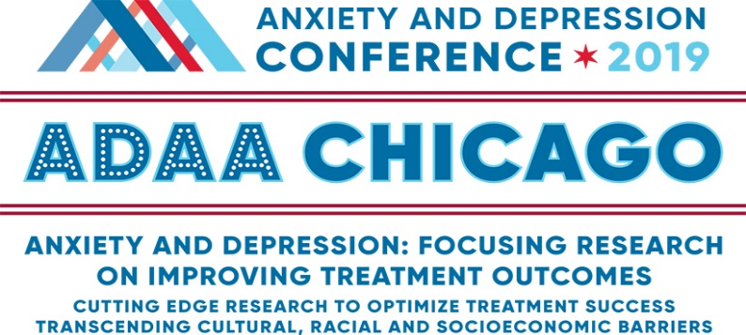

Registration Form
Anxiety and Depression Conference 2019
March 28-31, 2019

STEP 1. Choose Your Conference Registration Rate
ADAA Members
ADAA Member Category* | Early Bird  (Professional Members Only)  Ends 11/30/2018 | Early Rate  12/1/2018-2/1/2019 | Regular Rate  02/2/2019–03/31/2019
Professionals* | ☐ $450 | ☐ $500 | ☐ $600
Master’s Level Professionals* | ☐ $425 | ☐ $475 | ☐ $575
Trainees, Postdocs, Residents | ☐ $275 | ☐ $275 | ☐ $315
Students, Research Assistants | ☐ $180 | ☐ $180 | ☐ $220
Thursday Only (CE’s included) | ☐ $225 | ☐ $225 | ☐ $250
*Please note: In order to receive a member discount, membership must be valid through April 30, 2018.
**Continuing education credits (CEs) are included in registration fee for ADAA professional members.

Nonmembers
Individual Category | Early rate  through 02/1/2019 | Regular rate  2/2/2019-3/31/2019
Professionals | ☐ $760 | ☐ $860
Trainees, Postdocs, Residents | ☐ $410 | ☐ $450
Students, Research Assistants | ☐ $260 | ☐ $300
Continuing Education Credits (Professionals only) | ☐ $60 | ☐ $60
Thursday Only (CE’s $30 extra) | ☐ $300 | ☐ $325

STEP 2: Registration Information
First name __________________________ Last name_____________________________ Degree(s) _______________

Badge first name (if different from above) _________________________________________________________________

Current affiliation (as it should appear on your badge) ________________________________________________________

Full Address_______________________________________________________________________________________

Phone ______________________ Cell _____________________ Email ______________________________________

Emergency contact _________________________________________________ Cell/Phone ______________________

☐ I am applying for CE or CME credits (professionals only)… ☐ $0 for ADAA members ☐ $60 for nonmembers*
*Continuing education credits are included in the nonmember fee for LMSWs and LCSWs in New York State.
- Check one for CE or CME credits…☐ CME ☐ CME-MOC ☐ APA ☐ NASW ☐ NBCC ☐ CAMFT

STEP 3: Payment Information
Registration $ __________
CEs $ __________ (if applicable)
TOTAL $ __________
☐ Check #_____________________ ☐ VISA ☐ MasterCard ☐ American Express
Checks must be in U.S. $ and payable to ADAA. ADAA does not accept Discover.
Credit Card number _________________________________ Expires _____/______ 3- or 4-digit security code ________
Name on card ______________________________Authorized Signature ______________________________________
ADAA fully complies with the legal requirements of the Americans with Disability Act (ADA). Please list any special requirements: _____________________________________________________________________________________
☐ I have read the cancellation policy (below) and agree to the terms
*Event Insurance is available through online registrations only and with credit card purchase. U.S. Residents only. Visit our website for more information.

ADAA CONFERENCE REGISTRATION AND CANCELLATION POLICIES
Cancellation and Refunds: Cancellations and requests for refunds must be received in writing by March 11, 2019; cancellations by telephone will not be accepted. A $80s administrative fee will be charged for all refunds. Refunds will be issued after the conference ends.
- Cancellations will not be accepted after March 11, 2019, for any reason, including medical and travel complications, due to the many costs associated with planning and organizing this conference.
- Event insurance is available through online registration only. See our website for details.
Registration: Every individual attending the Anxiety and Depression Conference 2019 must register and pay the appropriate registration fee. All session and poster presenters must register immediately upon acceptance to the program.
- Students, trainees, postdoctoral fellows, and residents: You must provide a letter from your institution to be eligible for special reduced fees.
Confirmation and Badges: Registrants will receive confirmation by e-mail. Badges and conference schedule-at-a-glance will be distributed on-site. Badges are required for admission to sessions and should be worn at all times.
Payment: Payment in full is required at time of registration. ADAA accepts VISA, MasterCard, American Express, and checks in U.S. dollars ($30 charge for checks returned for insufficient funds). ADAA does not accept purchase orders or Discover.

