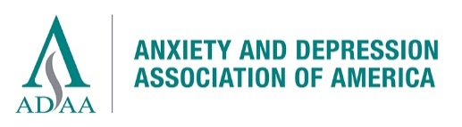

Donation Form

ADAA’s mission is to promote the prevention, treatment, and cure of anxiety, depression and co-occurring disorders through education, practice, and research.

Please accept my contribution to support ADAA:

☐$50 ☐$100 ☐$250 ☐$1,000 ☐$2,500 ☐ Other: $_____ ☐Please make my gift anonymous

☐ This gift is a Memorial/Honorarium: (please note that the minimum donation amount for an honorary/memorial gift is $10.00)
Donation amount: ☐$50 ☐$100 ☐$250 ☐$1,000 ☐$2,500 ☐ Other: $_____

In Memory of/In Honor of: (Name): _____________________________
Family Notification (Please provide the name and address of the individual or family member(s) you would like us to notify of your donation.):
Name: ___________________________________
Address: _____________________________________________________________________

Message: (If you would like to include a message to the family or individual, please include it in the text box provided and we will add your message with the notification)

Your Contact Information:

Name ______________________________________________________________________________
Address _____________________________________________________________________________
City _______________________________________ State/Province ___________ ZIP ______________
E-mail ________________________________________ Phone ________________________
☐ Yes, please add me to your email list

Method of Payment
Checks must be in USD and payable to ADAA:
☐ Check #__________ ☐ VISA ☐ MasterCard
($35.00 charge for returned checks) ADAA does not accept American Express or Discover.
Credit card # ________________________________ Expires Date _____________

RETURN THIS FORM:
- E-mail: donations@adaa.org (Download this form, fill it out, send as an e-mail attachment.)
- Mail: ADAA, 8701 Georgia Avenue, Suite 412, Silver Spring, MD 20910
You may also donate online at www.adaa.org. Thank you!

Retain this portion as a receipt for tax purposes.
Donation to Anxiety and Depression Association of America (ADAA) on _____________(date)
Amount $____________ Check #________ ☐ VISA ☐ MasterCard
ADAA is a 501(c)(3) nonprofit association. The IRS requires us to inform you that no products or services were given in return for your contribution.

