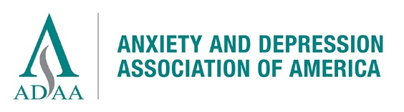

Emeritus Membership Renewal Notice

1. Member Profile
Name ___________________________________________ Email__________________________________

Address_________________________________________

City_________________ State________ Postal Code______________

I am fully retired, 67 years of age or older and have been an ADAA member for a minimum of 15 years.

2. MEMBERSHIP DUES

Emeritus • ($125/year) - Full ADAA benefits excluding being listed on Find-a-Therapist.

My Donation supports ADAA’s consumer education and outreach.
Accept my gift of ___$50 ___$100 ___$250 $_______Other
(Deductible to the extent of the law; consult your tax advisor.)

Total Payment to ADAA $___________

Method of Payment (U.S. dollars, payable to ADAA) Please note: $35.00 additional charge for returned checks
Check Postal money order (U.S. dollars) Visa MasterCard AMEX
Account__________-___________-__________-___________ Expires____ /_______ Security code________
Print Name on Card __________________________________________________
Authorizing signature_____________________________________________

Mail this form with payment to ADAA, 8701 Georgia Ave., #412, Silver Spring, MD 20910

For any changes or additions, please use the space on the other side

Please provide any contact information that has changed below:

_______________________________________________________________

________________________________________________________________

_________________________________________________________________

To update your profile, please login via the member login at www.adaa.org. Once logged in, go to Edit Bio.

If you need your login credentials or need assistance, please contact Lisa Patterson at lpatterson@adaa.org.

