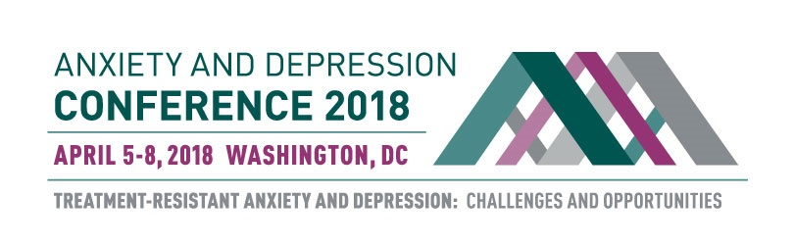
Registration Form
Anxiety and Depression Conference 2018
April 5-8, 2018

STEP 1. Choose Your Conference Registration Rate
ADAA Members
ADAA Member Category* | Early Bird  (Professional Members only) through 10/31 only | Early Rate  11/01/17–03/01/18 | Regular Rate  03/02/18–  04/04/18 | On-site  04/05/18  04/8/18
Professionals* | ☐ $440 | ☐ $499 | ☐ $599 | ☐ $624
Master’s Level Professionals* | ☐ $425 | ☐ $459 | ☐ $559 | ☐ $584
Trainees, Postdocs, Residents | ☐ $274 | ☐ $274 | ☐ $309 | ☐ $324
Students, Research Assistants | ☐ $175 | ☐ $175 | ☐ $210 | ☐ $225
Thursday Only (Master Clinicians and Timely Topics) | ☐ $229 | ☐ $229 | ☐ $229 | ☐ $249

*Please note: In order to receive a member discount, membership must be valid through April 30, 2018.
**Continuing education credits (CEs) are included in registration fee for ADAA professional members.

Nonmembers
Individual Category | Early rate  through 03/01/18 | Regular rate  03/02/18–04/4/18 | On-site  04/05/18-04/08/18
Professionals | ☐ $754 | ☐ $854 | ☐ $879
Trainees, Postdocs, Residents | ☐ $404 | ☐ $439 | ☐ $454
Students, Research Assistants | ☐ $260 | ☐ $295 | ☐ $310
Colleagues | ☐ $385 | ☐ $410 | ☐ $425
Thursday Only (Master Clinicians and Timely Topics) | ☐ $299 | ☐ $299 | ☐ $329
Continuing Education Credits (Professionals only) | ☐ $60 | ☐ $60 | ☐ $60

Please see Registration Information Form on Page 2

STEP 2: Registration Information
First name _________________Last name____________________ Degree(s) _______________

Badge first name (if different from above) ______________________________

Current affiliation (as it should appear on your badge) ______________________________________

Full Address_________________________________________________________________________

Phone ___________________ Cell ___________________ Email ______________________________

Emergency contact ___________________________________Cell/Phone __________________

☐ I am applying for CE or CME credits (professionals only)… ☐ $0 for ADAA members ☐ $60 for nonmembers*
*Continuing education credits are included in the nonmember fee for LMSWs and LCSWs in New York State.
- Check one for CE or CME credits…☐ CME ☐ CME-MOC ☐ APA ☐ NASW ☐ NBCC ☐ Other

STEP 3: Payment Information

Registration $ __________ CEs $ __________ (if applicable)

TOTAL $ __________

☐ Check #__________ ☐ VISA ☐ MasterCard ☐ American Express

Checks must be in U.S. $ and payable to ADAA. ADAA does not accept American Express or Discover.
Credit card number ____________________ Expires ______ 3- or 4-digit security code _______
Name on card __________________________
Authorized Signature ____________________ Date: ________________________

ADAA fully complies with the legal requirements of the Americans with Disability Act (ADA). Please list any special requirements:__________________________________________________________________ ___________________________________________________________________________________
ADAA CONFERENCE REGISTRATION AND CANCELLATION POLICIES
Cancellation and Refunds: Cancellations and requests for refunds must be received in writing by March 13, 2018; cancellations by telephone will not be accepted. A $80.00 administrative fee will be charged for all refunds. Refunds
will be issued after the conference ends.
- Cancellations will not be accepted after March 13, 2018, for any reason, including medical and travel
complications, due to the many costs associated with planning and organizing this conference.

Registration: Every individual attending the Anxiety and Depression Conference 2017 must register and pay the appropriate registration fee. All session and poster presenters must register immediately upon acceptance to the program. After March 25, 2018, registration will be available on-site only.

- Students, trainees, postdoctoral fellows, and residents: You must provide a letter from your institution to be eligible for special reduced fees.
- Guest fees—nonprofessional adults (family members and guests) who accompany registrants—provide access to non-ticketed meals and receptions. Guests are not eligible for CE or CME.
- Consumers: Register by phone (240-485-1030) or by mail by March 13, 2018, or on-site.
(Mail to ADAA, 8701 Georgia Ave., Suite 412, Silver Spring, MD 20910) Health professionals, faculty, and research staff are not eligible for consumer rates.

Confirmation and Badges: Registrants will receive confirmation by e-mail. Badges and conference schedule-at-a-glance will be distributed on-site. Badges are required for admission to sessions and should be worn at all times.

Payment: Payment in full is required at time of registration. ADAA accepts VISA or MasterCard, and checks in U.S. dollars ($30 charge for checks returned for insufficient funds). ADAA does not accept purchase orders or Discover.

