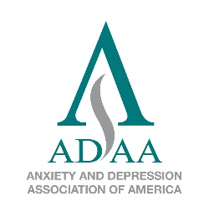
ANXIETY AND DEPRESSION ASSOCIATION OF AMERICA
8701 Georgia Ave., Suite 412, Silver Spring, MD 20910
Phone 240-485-1001 Fax 240-485-1035

www.adaa.org

Brochure Order Form

Brochures  $.50 per brochure (ADAA members)  $.95 per brochure (nonmembers) | Quantity | Price per Item* | Total
Obsessive-Compulsive Disorder (OCD) |  | X .50 /.95
Panic Disorder |  | X .50 /.95
Posttraumatic Stress Disorder (PTSD) |  | X .50 /.95
Social Anxiety Disorder |  | X .50 /.95
Anxiety Disorders in Children |  | X .50 /.95
Stress-Tip Cards (wallet size) |  | X .25
* 10% discount for 600 brochures or more | Subtotal |  | $
Shipping & Handling  1–100: $5.⁰⁰  101–200: $7.⁵⁰  201+ or outside the U.S., contact us. |  |  | $
 | TOTAL |  | $

Shipping and payment information on page 2

1

SHIP TO:

Name _________________________________________________________

Address _______________________________________________________

City ___________________________________________________________

State/Zip _______________________________________________________

Phone __________________________________

E-mail _________________________________________________________

METHOD OF PAYMENT

☐ Check #_________ ($35.00 additional charge for returned checks) ☐ VISA ☐ MasterCard
Checks must be in USD and payable to ADAA (No Amex or Discover Card)

Credit card #______________________________________ Expires_________ Security code________
Name on card_________________________________________________________________
Signature _________________________________________________ Date____________

RETURN THIS FORM
- E-mail membership@adaa.org (Download this form to your computer, fill it out, send as an e-mail attachment.)
- Mail ADAA, 8701 Georgia Ave., Suite 412, Silver Spring, MD 20910 Attention: Book Order
- Fax 240-485-1035
Thank you for your order!

2

