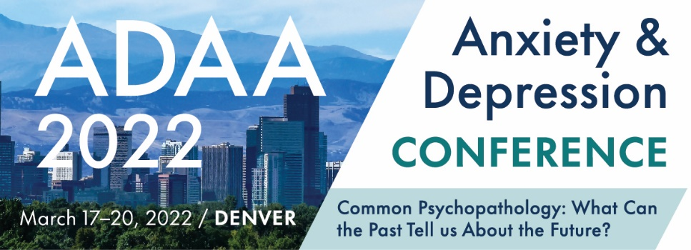

2022 Conference Submission Checklist

Primary Presenters/Chairs should have the following information ready before beginning their submission:
- Title
- Session Abstract/Description (3500 characters)
- Three Educational Learning Objectives
- Target Audience Level, Demographic, Disorder, and Treatment Approach Keywords
- Session Type (Roundtable, Symposia, Workshop)
- Co-presenter(s) name, degree, degree area of specialty, affiliation and email address
- Workshop Outline (Master Clinician and Workshops Only, 3000 characters)

- The primary presenter/chair can create, update, change, and finalize a submission.

- The primary presenter/chair may be the chair, presenter, or discussant and provides the title, session abstract, target audience level, learning objectives, and session type.

- The primary presenter/chair must provide the name, degree, affiliation, email address, and contact information for each presenter. Individual presenters can be invited to provide additional information through the submissions platform. When a session is selected all presenters will be prompted to log into their speaker portal and provide/update their contact information, complete their disclosure and registration agreement, and add additional information.

- The primary presenter/chair must finalize the submission once all information is complete. If you do not click all the way through the portal and submit your proposal it will not be considered complete.

- All submissions may be modified until the deadline or until formally submitted. All submissions must be complete by the deadlines listed below to be reviewed. No extensions will be granted. View the “How to Submit” guidelines for additional submission details.

Submission Type | Deadline
Master Clinician Sessions | Wednesday, September 1, 2021
Symposia, Workshops, Roundtables | Wednesday, September 22, 2021
Alies Muskin CDLP and Donald F. Klein Award | Wednesday, October 6, 2021
Posters | Wednesday, October 27, 2021

Questions? Email: conference@adaa.org

Please note: all conference participants (session participants and poster presenters) are required to participate in-person in Denver, CO March 17-20, 2022, and required to register for the conference at the appropriate registration fee.

