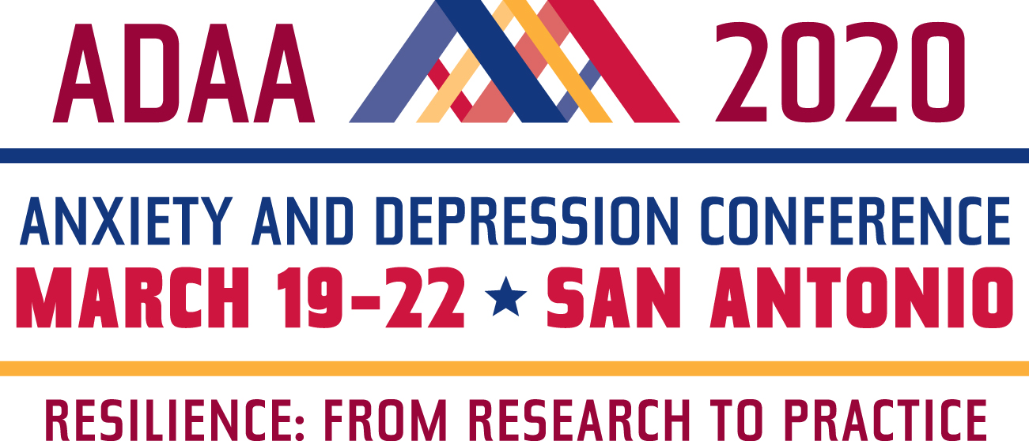

Group Registration Application
NOTE: To receive a group rate, each individual must have a current ADAA professional membership
paid through March 31, 2020. A minimum of four current members from the same practice or institution are eligible for the group rate. Join ADAA now. No group registrations accepted after March 2, 2020.

Group Registration  (professional members only) | Professional  (Masters Level) | Professional
Register by December 1, 2019 | ☐ $400 | ☐ $425
Register December 2 –February 3, 2020 | ☐ $450 | ☐ $475
Register February 4-March 2, 2020 | ☐ $550 | ☐ $575

________________________________________________________________________________________ Practice/Institution Contact Person Email

- ________________________________________ email _______________________________

- ________________________________________ email _______________________________

- ________________________________________ email _______________________________

- ________________________________________ email _______________________________

- ________________________________________ email _______________________________

- ________________________________________ email _______________________________

How to register your group:

- Return this form to membership@adaa.org for approval or fax it to 240-485-1035.
- Once approved, individual applications will be sent to each registrant in the group. Individual group registrations can be done online or by mail. Discount codes will be given to approved applicants.

- If paying for everyone by check, submit forms with payment for the entire group to this address:

Conference Registration, ADAA, 8701 Georgia Avenue, Suite 412, Silver Spring, MD 20910

Questions? Call ADAA at 240-485-1030 or email membership@adaa.org.

