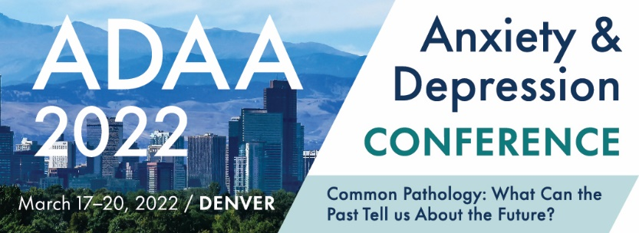

Registration Form

STEP 1. Choose Your Conference Registration Rate
ADAA Members
ADAA Member Category | Special Early Rate  (July 26, 2021 – Feb 21, 2022) | Regular Rate  (Feb 22, 2022 – Mar 20, 2022)
Doctoral Level Professionals  - Group Registration | $500  $475 | $600  $575
Masters Level Professionals  - Group Registration | $475  $450 | $575  $550
PostDocs/Trainees/Residents/Students/  Research Assistants | $180 | $220
*Please note: In order to receive a member discount, membership must be valid through March 31, 2022.

Non-Members – NEW FOR 2022 – Nonmember professional registration includes CE/CME Credit
Individual Category | Special Early Rate  (July 26, 2021 – Feb 21, 2022) | Regular Rate  (Feb 22, 2022 – Mar 20, 2022)
Doctoral Level Professionals | $770 | $870
PostDocs/Trainees/Residents/Students/  Research Assistants | $260 | $300
Colleague | $385 | $410
International Attendee From a Developing Country | $135 | $135
*Developing Countries are defined by the United Nations – please click here to see complete list.

Special Registration Rates for Colorado Residents Only
Registration Category | Special Early Rate  (July 26, 2021 – Feb 21, 2022) | Regular Rate  (Feb 22, 2022 – Mar 20, 2022)
Thursday Only Member Rate | $275 | $325
Thursday Only Nonmember Rate | $375 | $425
Thursday only rate includes: Master Clinician sessions, timely topics, refreshment breaks, Opening Session and Keynote, and Welcome Reception
Sunday Only Member Rate | $150 | $175
Sunday Only Member Rate | $250 | $275
Sunday only rate includes: Breakfast, breakout sessions, and one refreshment break.
Please note: One-day rates are open to Colorado residents only.
STEP 2: Registration Information

First name __________________________ Last name_____________________________ Degree(s) _______________

Current affiliation __________________________________________________________________________________

Full Billing Address_________________________________________________________________________________

Phone ______________________ Cell _____________________ Email ______________________________________

Emergency contact _________________________________________________ Cell/Phone ______________________

Would you like to share your pronouns on your badge? she/her he/him they/them zi/hir xe/xer
Prefer not to include pronouns on my badge.

I am applying for CE or CME credits (professionals only):
* Check one for CE or CME credits: CME CME-MOC APA NASW NBCC CAMFT
Please check where applicable:
- I am a Clinician Researcher Both Other Please list “other” _________________________
- I am a First Time Attendee Yes No
- I am a Session Presenter Poster Presenter
Do you have dietary restrictions? Vegetarian Vegan Kosher Gluten Free

ADAA fully complies with the legal requirements of the Americans with Disability Act (ADA).
Please list any special requirements:
________________________________________________________________________________________

STEP 3: Payment Information
Registration $ __________
Check #_____________________ VISA MasterCard American Express
Checks must be in U.S. $ and payable to ADAA. ADAA does not accept Discover.
Credit Card number _________________________________ Expires _____/______ 3- or 4-digit security code ________
Name on card ______________________________ Authorized Signature _____________________________________

I have read the conference and cancellation policies (below) and agree to the terms

__________________________________________
ADAA CONFERENCE, REGISTRATION, AND CANCELLATION POLICIES
Registration: Every individual attending ADAA’s 2022 Annual Conference must register and pay the appropriate registration fee. All session and poster presenters must register immediately upon acceptance to the program.
- Students, trainees, postdoctoral fellows, and residents must provide a letter from your institution to be eligible for special reduced fees.

Payment: Payment in full is required at time of registration. ADAA accepts VISA, MasterCard, American Express, and checks in U.S. dollars ($30 charge for checks returned for insufficient funds). ADAA does not accept purchase orders or Discover.
Registration Cancellation Insurance: ADAA is pleased to offer the opportunity for attendees to independently purchase registration insurance through the Registration Saver program offered by Next Wave. ADAA encourages all attendees to consider this option. Attendees who purchase registration insurance and who must cancel their attendance will be prompted to process a claim through this program as their first refund step. Should the cancellation not qualify for reimbursement under the Next Wave insurance program and ADAA’s cancellation deadline has not past, ADAA’s traditional cancellation policy (see below) and administrative fees apply.
Cancellation and Refunds: Cancellations and requests for refunds must be received in writing by February 17, 2022; cancellations by telephone will not be accepted. A $50 administrative fee will be charged for the Trainees, Postdocs, Residents, Students, Research Assistants and International Attendee Working in a Developing Country registration levels for cancellations. A $100 administrative fee will be charged for all other registration levels for cancellations. Refunds will be issued post-Conference. Cancellations will not be accepted after February 17, 2022 for any reason.

COVID-19 Policies:
ADAA is committed to following all CDC guidelines related to the COVID-19 pandemic as well as state, local, and corporate (hotel) requirements to be mindful of the safety of attendees, partners, and staff.

Any public space where other people are present may hold an inherent risk of exposure to COVID-19 and other communicable diseases. By attending this event, I agree to voluntarily assume all risks related to exposure and agree to not hold ADAA or any of their affiliates including partners, sponsors, employees, volunteers, or sponsored venues liable for illness.

ADAA requires proof of vaccination from each conference participant (speaker, attendee, sponsor, staff, etc.) to attend all conference activities. Medical exemptions may be accepted with a negative COVID-19 test performed by a professional testing facility (home test results will not be accepted) administered no more than 72 hours prior to the conference dates. I agree to provide required documentation in order to attend. I understand if appropriate documentation is not provided, I will not be permitted entry into the conference and no refund will be issued.

I will take necessary precautions and follow required guidelines while at the event including, but not limited to, engaging in appropriate social distance, wearing a mask in conference spaces when not actively eating/drinking or presenting at a podium, minimizing face touching, frequently washing hands, and avoiding risky environments such as overcrowded restaurants. I agree not to attend any ADAA event if I feel ill or had an exposure to a COVID-19 case within 14 days of the conference.

I acknowledge that due to the impact of COVID-19 that room capacities may be reduced due to social distancing and all sessions, unless pre-registered, are on a first-come, first-served basis. To maintain required spacing, I will not move chairs or adjust seating arrangements within conference event spaces.

