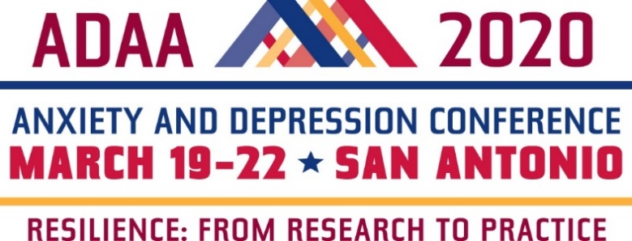

Registration Form
Please email completed form to membership@adaa.org

STEP 1. Choose Your Conference Registration Rate
ADAA Members
ADAA Member Category* | Super Early  Rate  Professionals  Members Only | Early Rate  12/2/2019- 2/3/2020 | Regular Rate  02/4/2020–03/22/2020
Professionals* Use Code EarlyPro20 at checkout | $450 | $500 | $600
Master’s Level Professionals* Use Code EarlyPro20 at checkout | $425 | $475 | $575
Trainees, Postdocs, Residents | n/a | $275 | $315
Students, Research Assistants | n/a | $180 | $220
Thursday Only (CE’s included) March 19, 2020 | n/a | $275 | $325
Sunday Only (CE’s included) March 22, 2020 | n/a | $150 | $250
*Please note: In order to receive a member discount, membership must be valid through March 31, 2020. If you register at the member rate, but do not renew your membership when due, you will be charged the non-member rate.
**Continuing education credits (CEs) are included in registration fee for ADAA professional members only.

Non-Members
Individual Category | Early rate  through 02/3/2020 | Regular rate  2/4/2020-3/22/2020
Professionals | $770 | $870
Trainees, Postdocs, Residents | $410 | $450
Students, Research Assistants | $260 | $300
Continuing Education Credits (Professionals only) | $65 | $65
Thursday Only (CE’s $35 extra) March 19,2020 | $375 | $425
Sunday Only (CE’s $35 extra) March 22, 2020 | $250 | $275

*Event Insurance (through Allianz) is available through online registrations only and with credit card purchase. U.S. Residents only. If you wish to purchase insurance and plan to pay by check, please contact ADAA. Visit our website for more information.
STEP 2: Registration Information
First name __________________________ Last name_____________________________ Degree(s) _______________

Badge first name (if different from above) _________________________________________________________________

Current affiliation (as it should appear on your badge) ________________________________________________________

Full Billing Address_________________________________________________________________________________

Phone ______________________ Cell _____________________ Email ______________________________________

Emergency contact _________________________________________________ Cell/Phone ______________________

I am applying for CE or CME credits (professionals only): ☐ $0 for ADAA members ☐ $65 for nonmembers
Thursday Only Registrants Seeking CE or CME Credits: ☐ $0 for ADAA members ☐ $30 for nonmembers
* Check one for CE or CME credits: CME CME-MOC APA NASW NBCC CAMFT
Please check where applicable:
- I am a Clinician Researcher Both Other Please list “other” ________________________
- I am a First Time Attendee Yes No
- I am a Session Presenter Poster Presenter
- Dietary Restrictions Vegetarian Vegan Kosher Gluten-Free

STEP 3: Payment Information
Registration $ __________ CEs $ __________ (if applicable) TOTAL: $ __________
Check #_____________________ VISA MasterCard American Express
Checks must be in U.S. $ and payable to ADAA. ADAA does not accept Discover.
Credit Card number _________________________________ Expires _____/______ 3- or 4-digit security code ________
Name on card ______________________________ Authorized Signature _____________________________________
ADAA fully complies with the legal requirements of the Americans with Disability Act (ADA).
Please list any special requirements: ___________________________________________________________________
I have read the cancellation policy (below) and agree to the terms

Please email completed form to membership@adaa.org
__________________________________________
ADAA CONFERENCE REGISTRATION AND CANCELLATION POLICIES
Registration: Every individual attending #ADAA2020 must register and pay the appropriate registration fee. All session and poster presenters must register immediately upon acceptance to the program.
- Students, trainees, postdoctoral fellows, and residents: You must provide a letter from your institution to be eligible for special reduced fees.
Confirmation and Badges: Registrants will receive confirmation by e-mail. Badges and conference schedule-at-a-glance will be distributed on-site. Badges are required for admission to sessions and should be worn at all times.
Payment: Payment in full is required at time of registration. ADAA accepts VISA, MasterCard, American Express, and checks in U.S. dollars ($30 charge for checks returned for insufficient funds). ADAA does not accept purchase orders or Discover.
Cancellation and Refunds: Cancellations and requests for refunds must be received in writing by March 5, 2020; cancellations by telephone will not be accepted. A $80.00 administrative fee will be charged for all refunds. Refunds will be issued post-Conference.
- Cancellations will not be accepted after March 5, 2020, for any reason, including medical and travel complications, due to the many costs associated with planning and organizing this conference.
- Event insurance is available through online registration only. See our website for details.

