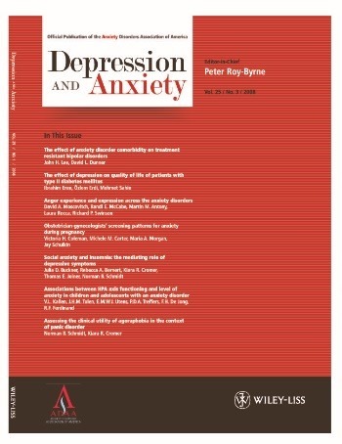



Dear ADAA Member**,**

As part of your membership with the **ADAA** you are entitled to online access to **Depression and Anxiety** via ***Wiley Online Library***.

Featuring a clean and simple interface, *Wiley Online Library* delivers intuitive navigation, enhanced discoverability, expanded functionalities, and a variety of personalization and alerting options. Registered Users may sign up for new journal content email alerts & RSS feeds, as well as search for related content elements and click through to references.

If you are a new Wiley Online Library user, follow these simple steps to **Register** and **Activate** your *ADAA Membership* access. (If you are already a registered User on *Wiley Online Library* skip to **Step B** to activate your membership access.)

**Step A.       Register**

1. Go to the ***Wiley Online Library*** homepage: [http://onlinelibrary.wiley.com](http://onlinelibrary.wiley.com/)
2. Click on “Register” at the top right hand part of the page.
3. Fill in the Registration form and submit.
4. You will immediately receive an email which requires you to click on a link and validate the information you provided during your registration. Please do so within 24 hours in order to avoid the need to re-register.
5. Once you have registered, log in and follow the instructions in Step B below to affiliate your journal with your account.

**Step B**.  **Activate**

1. Go to the ***Wiley Online Library*** Member Registration homepage: <http://onlinelibrary.wiley.com/societies/DAeonly>
2. Enter your registered email address and password.
3. Enter your Membership Number: **ADAA**
4. Enter your Access Code: **MBR65246**
5. Click ‘Submit’

Registration and activation is a one-time process. In the future simply visit [Depression and Anxiety on Wiley Online Library](http://onlinelibrary.wiley.com/journal/10.1002/(ISSN)1520-6394) and login with your registered user email address and password.

Access to this online journal is for personal use only and your password should be kept confidential.

Full contact details for Membership Services can be found at: [www.wileycustomerhelp.com](http://www.wileycustomerhelp.com)